Link to our repository:  
<https://S522581@bitbucket.org/team5c/hidden-leaf.git>

Updated List of my commits:

1. [March 31 - Added whole admin modules and all its related controllers](https://bitbucket.org/team5c/hidden-leaf/commits/1d6abdf382b0a9f3ebcab429c612f216fc2a2b3e)
2. [March 24 - Reverted Changes](https://bitbucket.org/team5c/hidden-leaf/commits/4a2b32d6aa7351d4a33b49cf2f4d849448e717de)
3. [March 24 - Added the Admin controller and the main page](https://bitbucket.org/team5c/hidden-leaf/commits/355312679d15abdf333a92ef766d2ee276bb9779)
4. [March 24 - Deleted Migrations to fix some issues](https://bitbucket.org/team5c/hidden-leaf/commits/d1ea748f27fdbfb1232edd96826eddd7ea4baac9)
5. [March 19 - Removed Controllers for creating my own](https://bitbucket.org/team5c/hidden-leaf/commits/fcb1fb2e356ef9a749b1fc11a3ad917ef86deca9)

Contributions:

1. I have handled the admin module for my team and my project – Aquatix
2. In admin module, I dealt with creating events/listing events/modifying it and deleting it.
3. Created Coupons for the Aquatix events.
4. Monitoring the transactions which the user has placed.
5. Monitoring the users, viewing them and deleting them, if found hoax.
6. Monitoring special occasions, creating them and dealing with it.

Challenges & Bug Fixes:

1. We have faced issues over the AccountUser controller where vijay helped me today.
2. I personally faced many issues to relate other’s tasks in admin, now its fine.
3. Issues were related to DNX supporting Entity Frameworks, using multiple models on a single page, retrieving multiple views from only one controller.
4. Merging issues in which each and every team member worked hard.
5. Sharanya and Vijay are the great asset for the team, their experience is really helping this project to go forward.

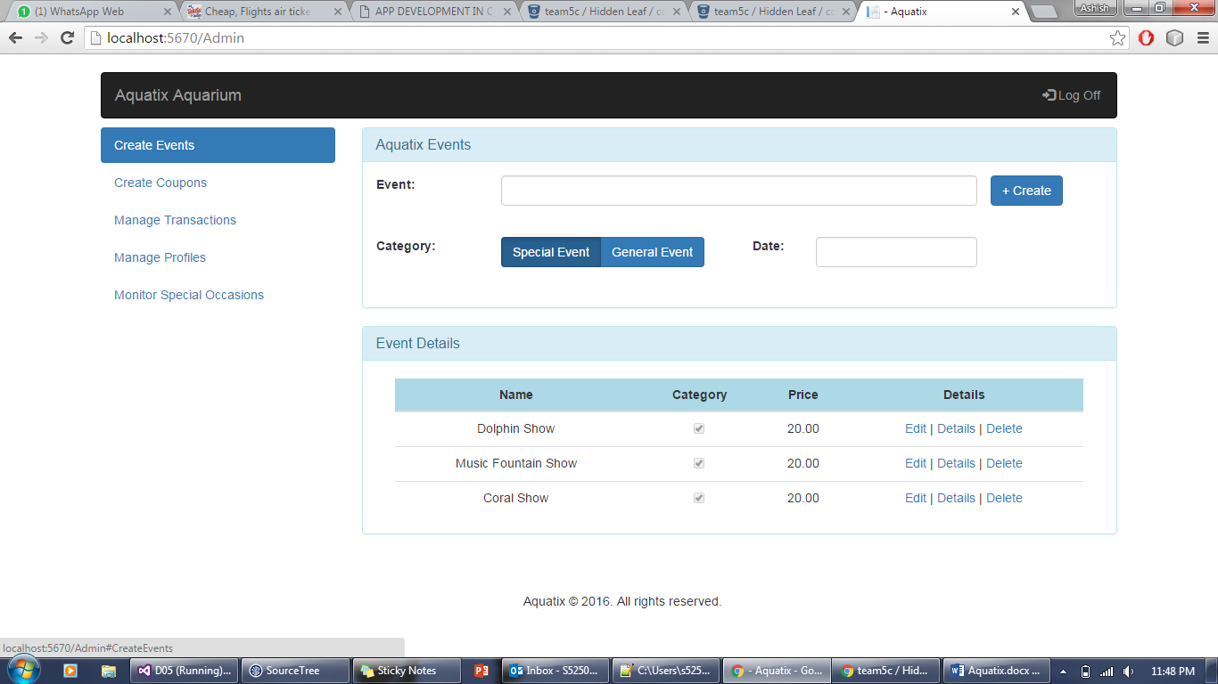

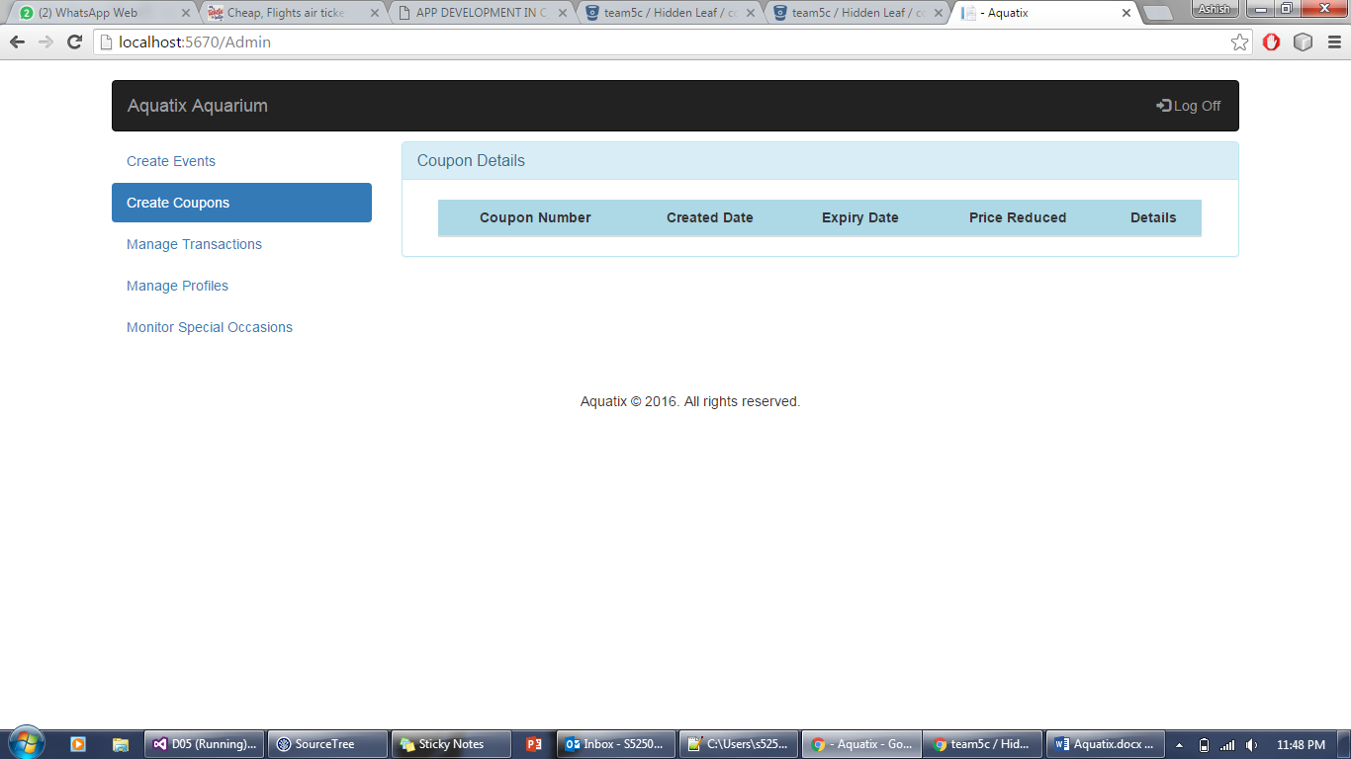

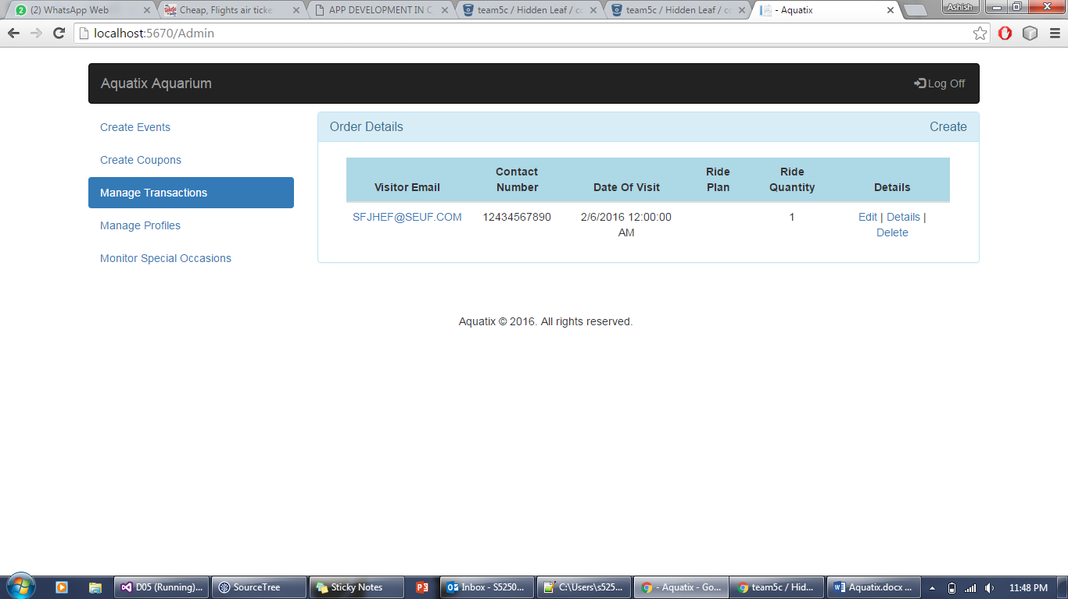

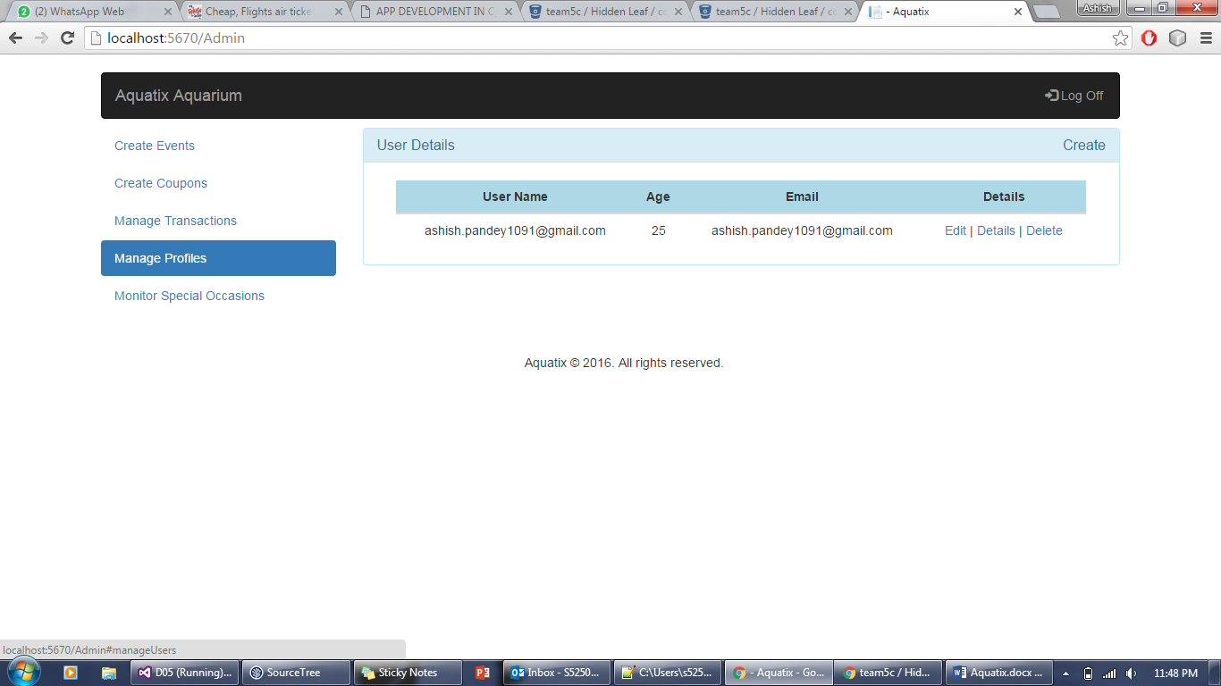

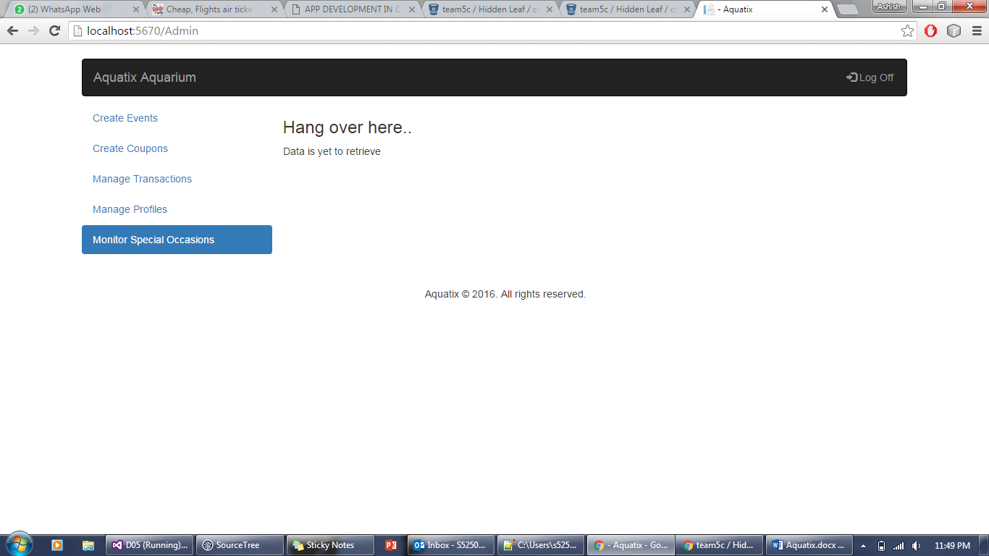

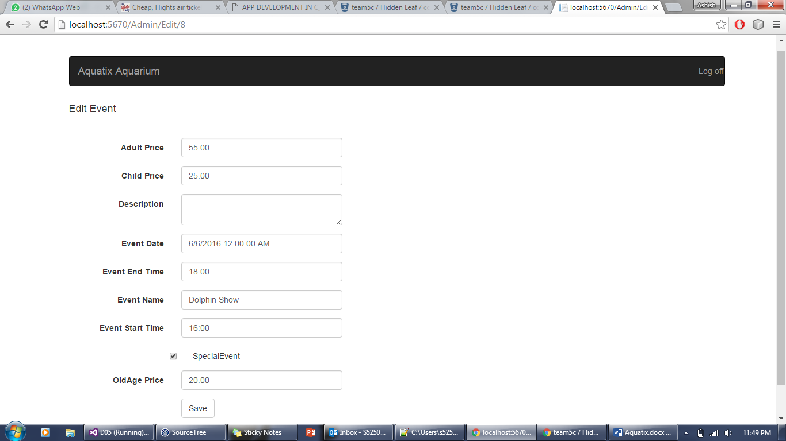

Cost of our project:

It would be around 5000 $.

I would charge for admin module around 300$ as it is the contribution of whole team.

Our team has earned around 4600 $ for this project.